Assignment # 53-57 JAVASCRIPT

Events

- Consider you have 4 images in a file as shown below:
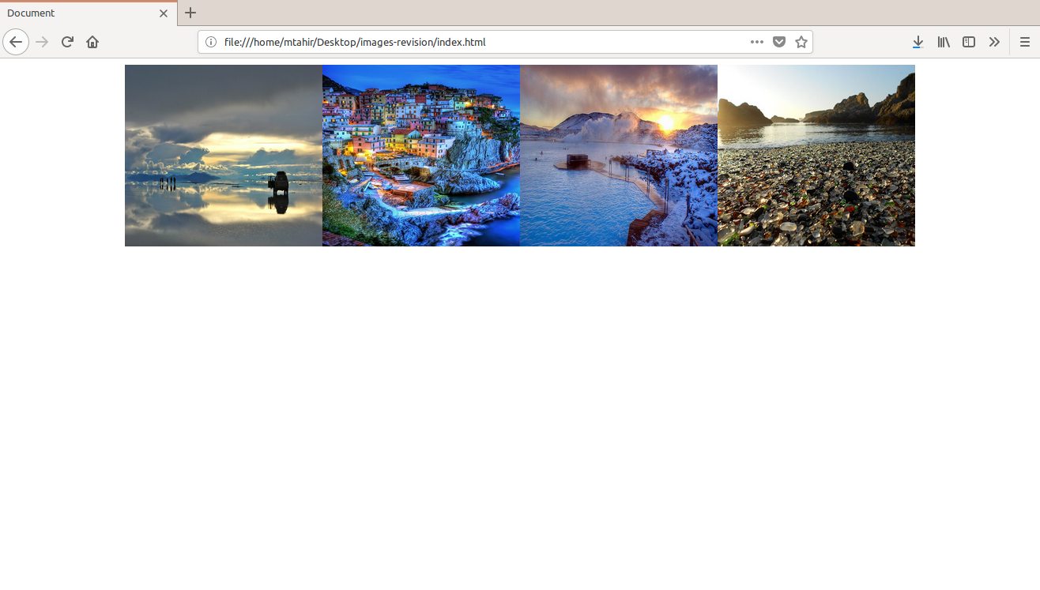

Now When you click on an image it should display in a modal.
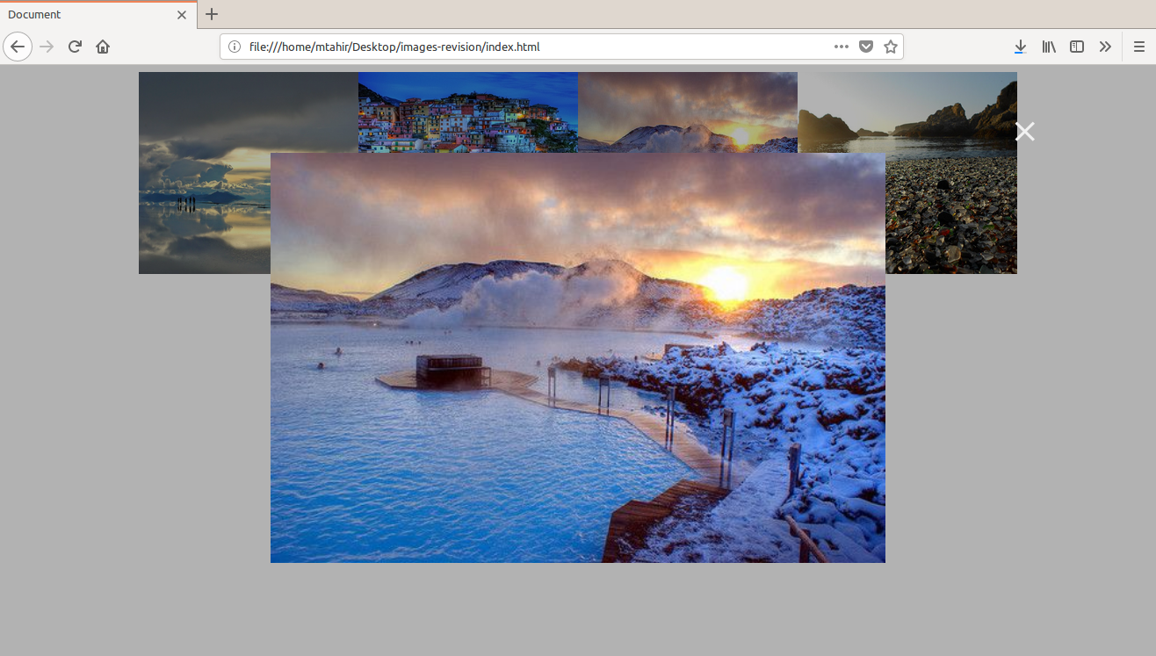

Modal code is available in this assignment file.
2. Create a paragraph and two buttons “zoom in ”(+) and “zoom out”(-).
On each click on “zoom in”(+) , add 10px in font size of paragraph.
And on each click on “zoom out”(-) , minus 10px in font size of paragraph.

